UZIO Overview: Platform, Modules, Key Features

What is UZIO? 1
Modules of UZIO Platform 2
Time Tracking & Scheduling 2
Time off 4
Payroll 5
HR Onboarding 7
Benefits 8
Accessible Platforms 13
Employer Portal 13
Employee Portal 13
UZIO Mobile App 14
UZIO Kiosk 15
Account Setup 16
Setting Up Employer Account 16
Setting Up Employee Account 16
Login as Employer 17
Login as Employee 17

What is UZIO?
UZIO is an all-in-one HR, payroll, benefits, and time platform that centralizes people operations—covering payroll and tax, HRIS, benefits/, time & attendance, expenses, compliance, and reporting. UZIO Co-Pilot is in-app AI assistant that answers questions, automates routine actions, and guides admins through complex HR, Payroll, and Benefits workflows to reduce time-to-completion.

Modules of UZIO Platform

Time Tracking & Scheduling
UZIO’s Time Tracking and Scheduling module lets teams capture time exactly where work happens—on the web, in the Employer/Employee portals, the UZIO Mobile App, or a shared Time Kiosk. Employees clock in/out, record meals and rests, and see their hours in one place, while managers get a clean review flow for daily checks and end-of-period approvals. Everything is designed to be quick for frontline users and auditable for admins, so you reduce corrections and speed up payroll.
Break compliance is built in. You can define meal and rest policies (paid or unpaid), set eligibility thresholds and repeat rules, and choose whether to auto-deduct or simply flag missing breaks for attestation. This gives you the flexibility to match local laws and company policy without forcing a one-size-fits-all rule across teams. When exceptions occur, they’re visible and traceable—so you can correct issues before they reach payroll.
Scheduling is just as streamlined. Managers create and publish shifts, make updates, and ensure coverage across locations or roles. Employees see their assigned shifts on web and mobile as soon as schedules are published, helping reduce no-shows and last-minute confusion. Simple controls keep the learning curve low, so planners can move quickly even during high-change periods.
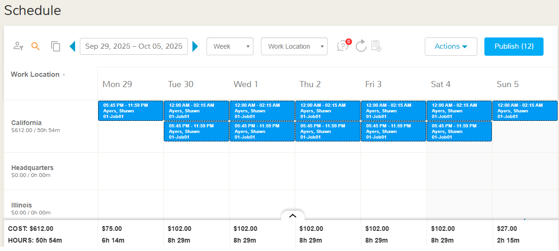
Managers can publish Open Shifts for eligible employees to claim on mobile. Employees can Offer their assigned shift to coworkers or request a Swap; these actions route to managers for approve/decline, and once published, updates hit everyone’s calendars. Eligibility rules (e.g., same work location) are enforced so coverage changes stay compliant and auditable.
Manager workflows tie the whole process together. You can monitor who’s on the clock right now, review timesheets for your direct reports, approve or send back changes, and sync hours to payroll when they’re final. Because time and schedules live in the same system as HR and payroll, data flows forward with fewer exports, fewer manual edits, and a clear audit trail from shift plan → time worked → payroll.
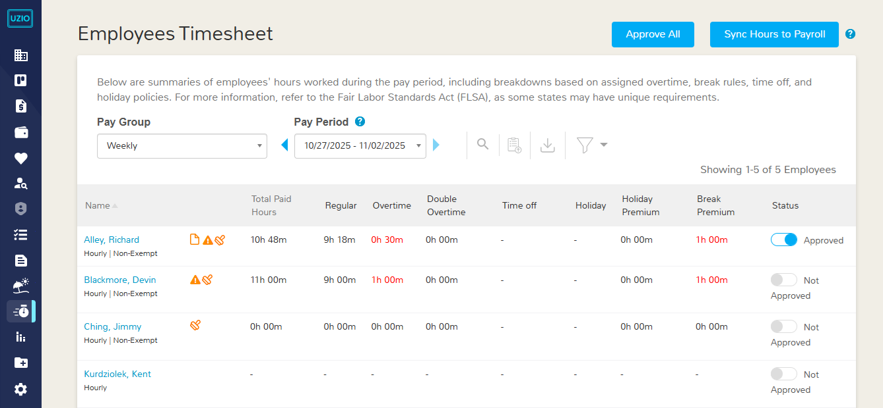

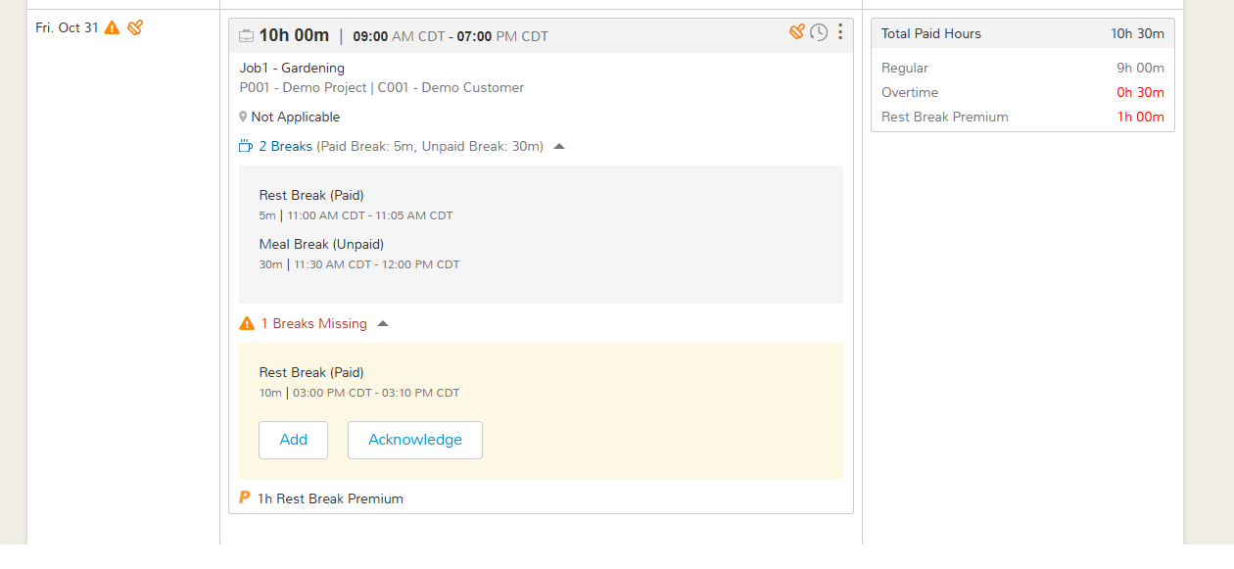

Time off
UZIO’s Time Off module gives employees a clear, self-service experience to request time off, check balances, and track history from the web and the UZIO Mobile App. On web, employees hit Request Time Off, enter dates, reasons, and see their current balances before submitting. On mobile, Time Off lives right in the bottom navigation so people can request from anywhere without emailing HR.
For admins, policies and holidays are centralized and configurable. You can add and manage Time Off policies, then assign them to employees; holiday calendars are created from the same area so observed holidays flow into balances and availability. This keeps policy rules and holidays consistent across teams and locations.
The approvals flow is built in. Employees submit; managers are notified and can approve/deny with notes. Admin dashboards let you review pending requests at a glance, reducing email back-and-forth and keeping decisions auditable. That visibility cuts down on surprises at payroll time and makes it easy to enforce blackout dates or staffing minimums.
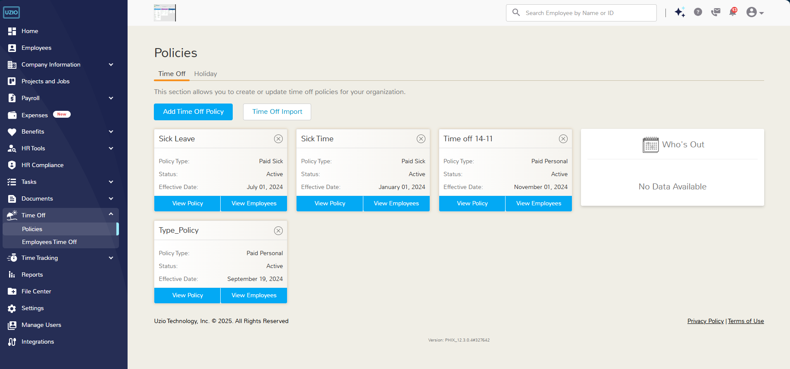
Finally, Time Off is wired to payroll and scheduling. Approved PTO and unpaid time off sync to payroll and, for salaried employees, regular hours adjust automatically when unpaid time is used. If your PTO accrues off hours worked, using UZIO for both Payroll and PTO ensures automatic accrual calculations without manual reconciliation. This end-to-end flow moves you from policy → request → approval → pay with fewer errors.

Payroll
UZIO Payroll starts with clean setup so every run is predictable. You define pay groups and pay schedules (weekly, bi-weekly, semi-monthly, etc.), pick first pay dates, and make sure your payroll calendar aligns with benefits cut-offs so per-pay-period deductions calculate correctly. Once company and banking details are in place, this foundation prevents most downstream errors and makes reviews faster.
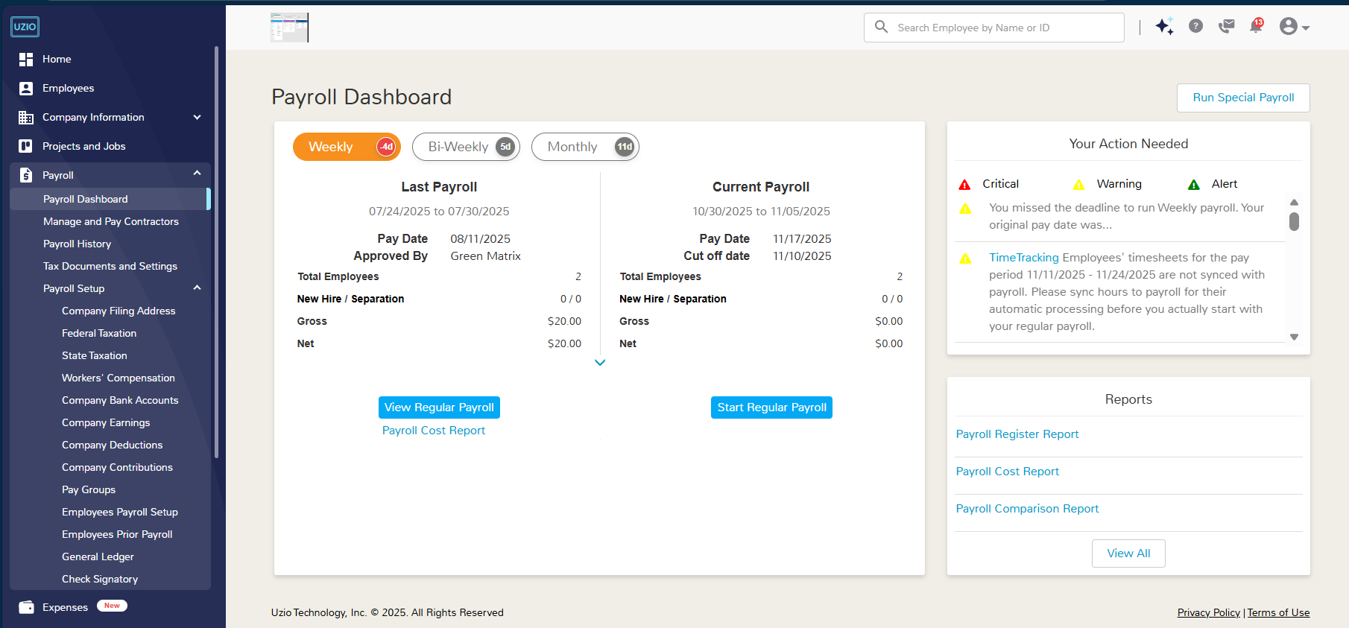
Running payroll follows a guided flow: load hours and earnings, review taxes and net pay, then approve. You can handle regular payrolls and special/off-cycle runs (e.g., bonuses or corrections), and a recent enhancement lets admins process regular and special payrolls at the same time when timelines are tight. The system also documents how bank holidays impact timing so you can plan approvals and fundings with confidence.
Admins can fine-tune results without breaking auditability. Common tasks include salary proration, overriding deduction/contribution methods, and making targeted employee payroll updates (earnings, deductions, contributions, direct-deposit changes for employees without portal access, etc.). These controls help you correct edge cases in the current cycle while keeping the underlying setup stable for future runs.
Taxes and year-end are built into the flow. UZIO documents how tax payments (impounds) are scheduled and debited relative to check dates and due dates, so finance teams can reconcile cash movement. On the employee side, the help center explains the W-2 form and provides guidance for downloading W-2s, with updates noting mobile access to W-2s as well. For bonuses or gift cards, gross-up tools calculate the necessary tax to land a target net.
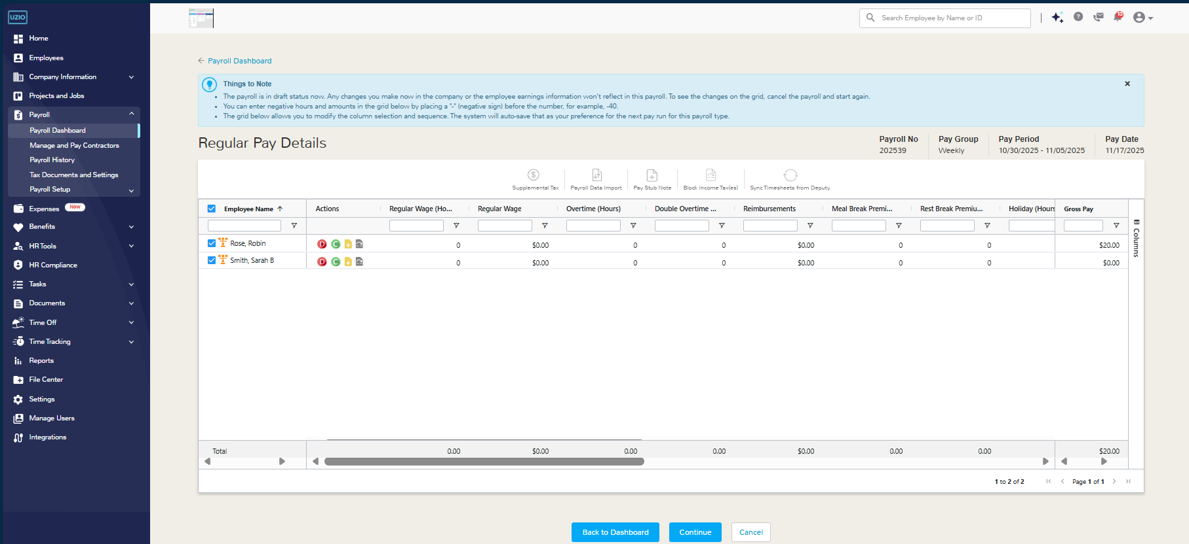
Accounting and reporting close the loop. UZIO offers a two-way QuickBooks Online integration with per-component mapping (earnings, employee deductions, employer taxes/contributions) and clear syncing rules (e.g., sync after approval). Finance users can also build custom payroll reports from the Reports tab to analyze costs, taxes, and liabilities over time. Together, these features reduce spreadsheets, keep the ledger in sync, and make audits straightforward.
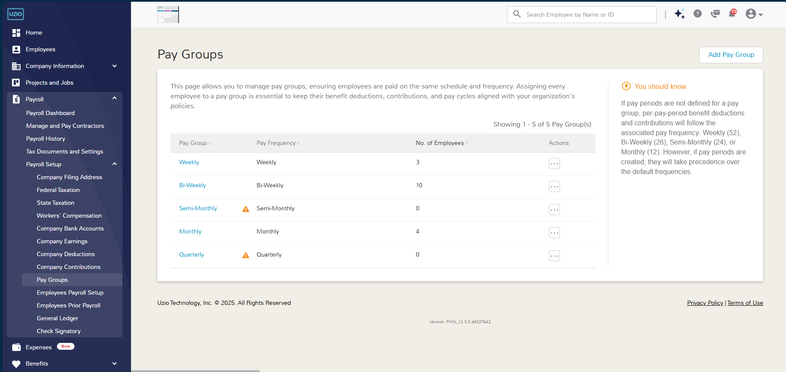

HR Onboarding
UZIO’s Hire & Onboarding brings candidates into your system with minimal back-and-forth. You can add a prospective employee, choose whether the employer completes the forms or send a self-onboarding invite so the candidate fills in their details, and then track progress from a single status view. This two-path approach (employer-driven or self-service) keeps momentum up while giving admins full visibility.
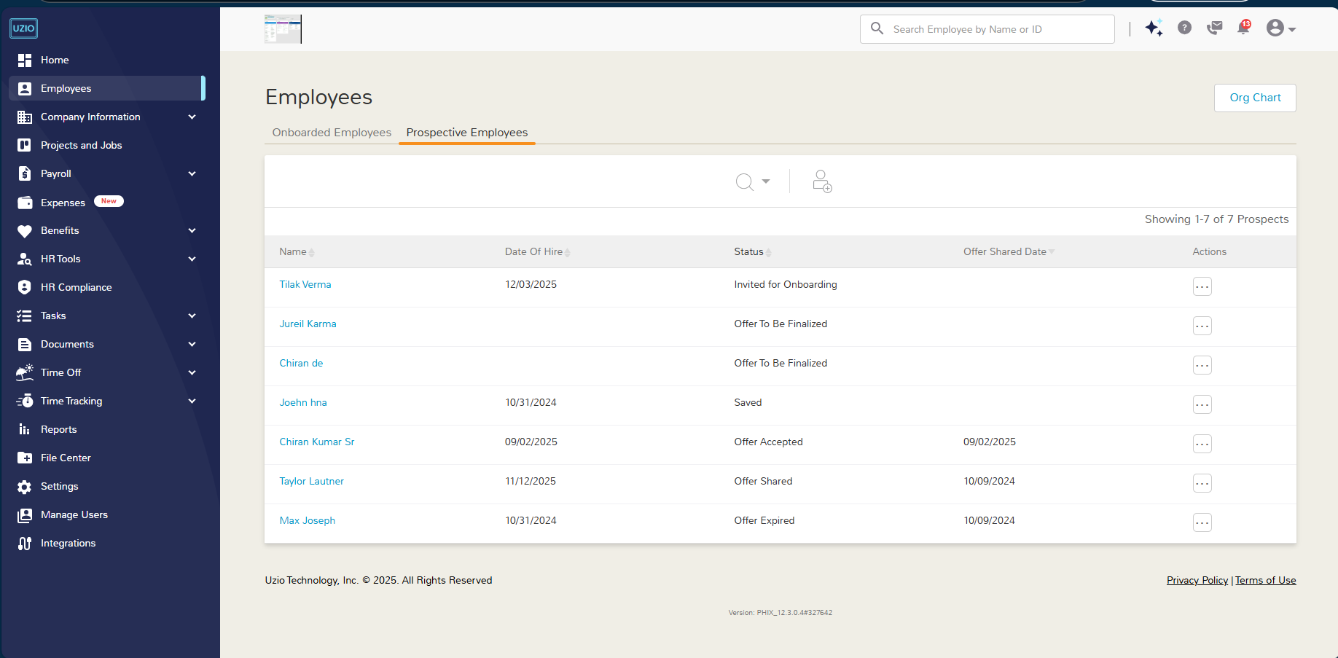
On the Hiring side, you can configure offer letters and supplemental documents (handbooks, policies) once and reuse them across roles. If your workflow includes screening, UZIO documents an integration with Checkr for background checks, and for work authorization, there’s a built-in integration with Clear I-9 to manage I-9/E-Verify for onsite or remote hires. These pieces reduce manual steps and keep sensitive compliance tasks inside one flow.
The Documents area acts as your onboarding content library. Admins can add custom employee documents, organize them with custom categories, and point managers to the exact place to upload or assign paperwork from the employer portal.
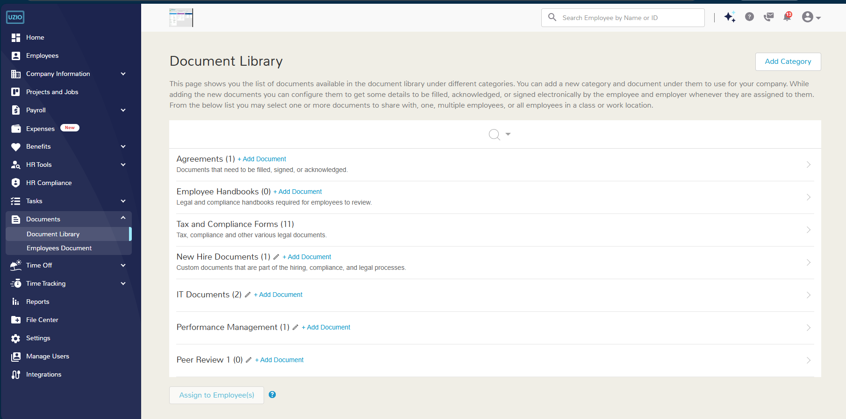
UZIO’s Tasks make the process trackable. A task is simply a to-do with a due date and owner; your Task Library centralizes onboarding, offboarding, and ongoing tasks so you can reuse checklists. Set up onboarding/offboarding task lists in settings, assign them to the right people, and monitor completion as part of each hire’s status—no spreadsheets required.
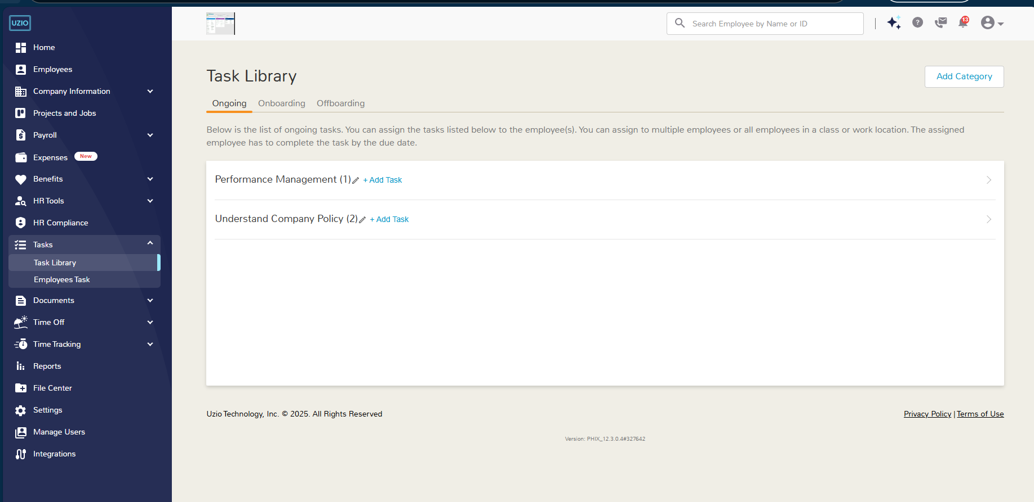

Benefits
UZIO’s Benefits module digitizes the entire benefits lifecycle for employers, brokers, and employees—so you can configure plans, publish packages, and manage changes year-round without paper forms. Employers get a guided setup to approve and share benefit packages, while brokers manage plan design and servicing across their book. Employees enroll online and can update coverage when eligible (new hire, open enrollment, or life events).
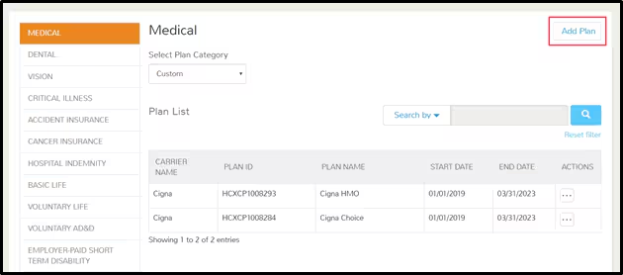
Plan building is structured and reusable. You can load plans and rates (medical, dental, vision, etc.), define eligibility classes (grouping by role/location), and set contribution strategies (fixed dollar, percent, tiers for dependents). A Decision Support System (DSS) helps compare plan designs so you can present the right mix by cost and coverage before publishing packages.
Enrollment is built for real life. Admins can run new-hire enrollments, open enrollment, and mid-year enrollments when adding clients or moving groups mid-cycle. The Enrollments dashboard shows participation and completion status, and product updates.
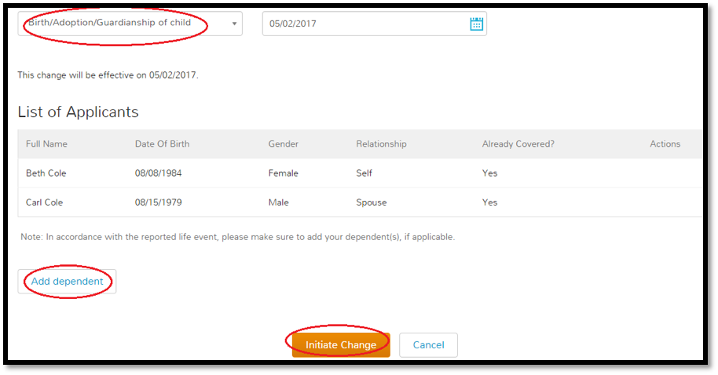
Renewals are streamlined. At plan year change, you can roll over coverage and select replacement plans where necessary—then monitor the impact through Enrollment and Financial dashboards for cost visibility. On the employee side, help articles confirm that workers enroll from the portal and can access their elections and premiums at any time; mobile FAQs reinforce that eligibility and enrollment happen through the employee portal.
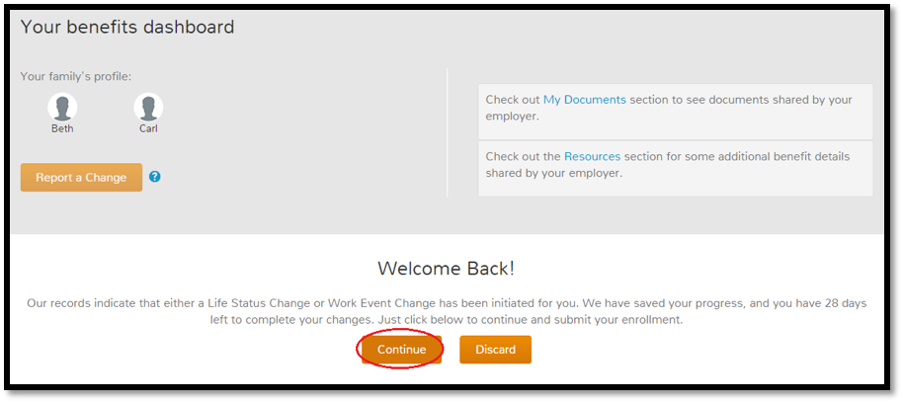
Finally, benefits data doesn’t live in silo. UZIO payroll system automatically pulls the deductions and contributions from the benefits and process in the payroll.
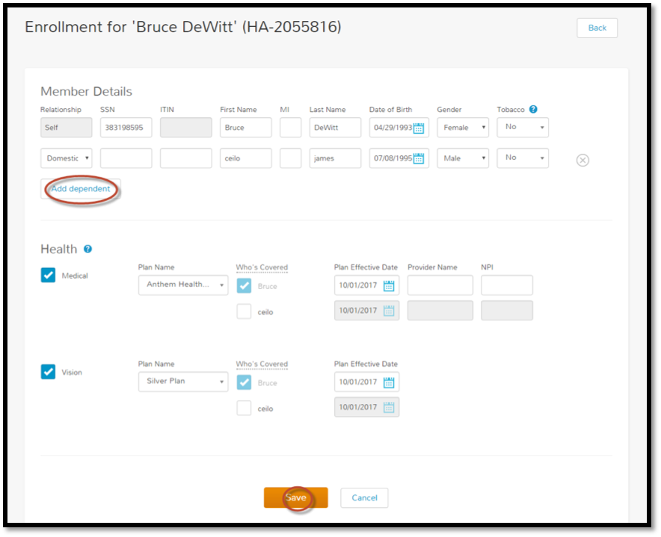
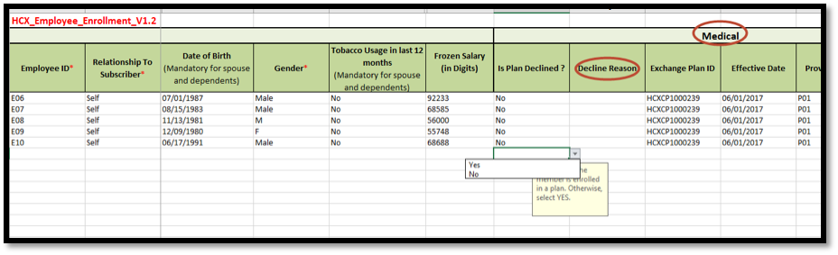
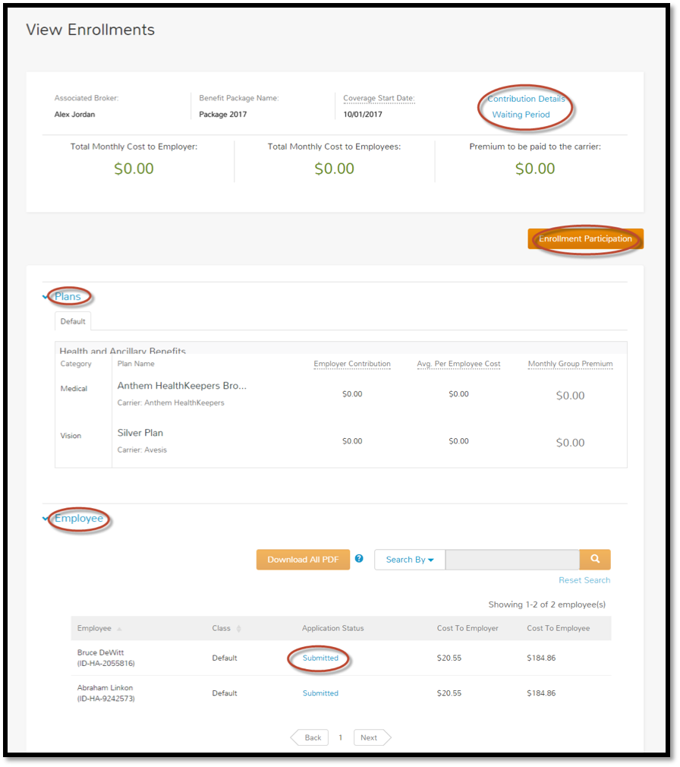

Accessible Platforms

Employer Portal
Employer Portal is the command center for admins and managers. From here you can run payroll, review and approve time sheets, manage time and break rules, and keep an eye on benefits via Enrollment and Financial dashboards. Admins can also manage user access (e.g., limit employer users to specific work locations) and handle everyday HR tasks like adding or terminating employees. This portal is where setup decisions (pay schedules, policies, roles) turn into day-to-day actions.
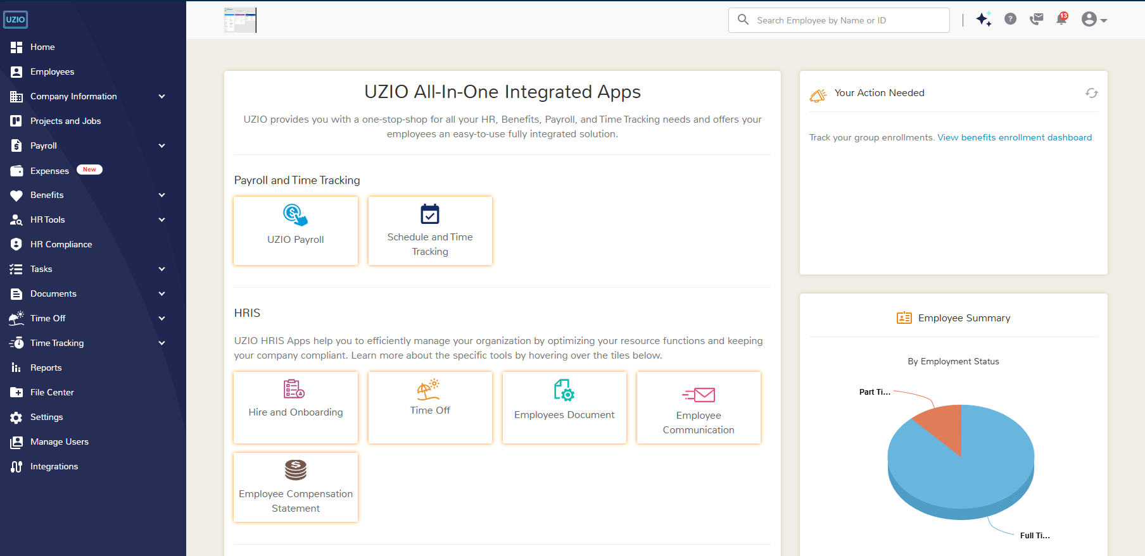

Employee Portal
Employee Portal gives every worker a single place to use time tracking, request and manager time off, complete benefits enrollment, see pay stubs and W-2s and update tax withholding details and direct-deposit details on the web. It also includes documents and task completions, view the historical data of benefits and self-service help for login and password resets so employees can get back in quickly without HR intervention. This keeps payroll and HR data accurate at the source while reducing back-and-forth with administrators.
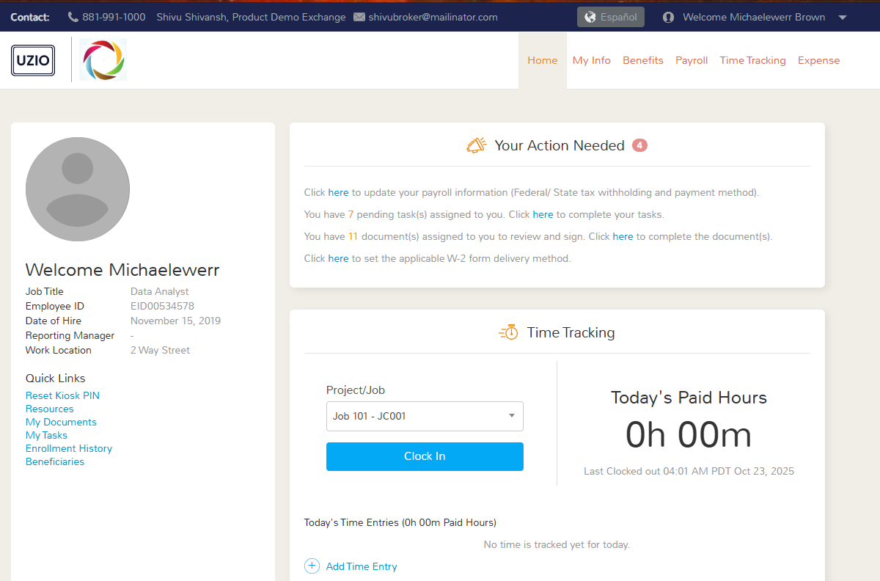

UZIO Mobile App
On the go, employees can do the essentials from the UZIO Mobile App: clock in/out and track breaks, view pay stubs, check balances and request time off, view and manage schedule, and (if enabled) manage timesheets and time off for direct reports. It’s the same data as the web portals, optimized for quick actions from a phone.
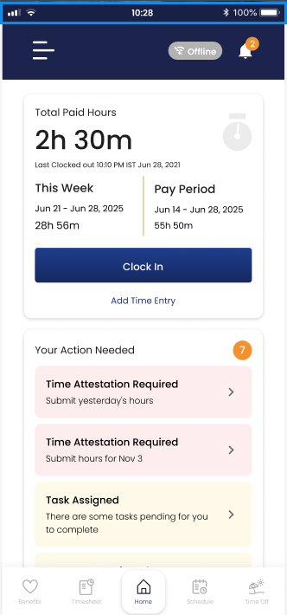

UZIO Kiosk
For shared worksites, the browser-based Time Kiosk lets employees clock in/out, take meal/rest breaks, and interact with assigned shifts on a common device. Employers configure the kiosk and link it to the right location/policy set, giving frontline teams a simple way to capture accurate time without individual smartphones.
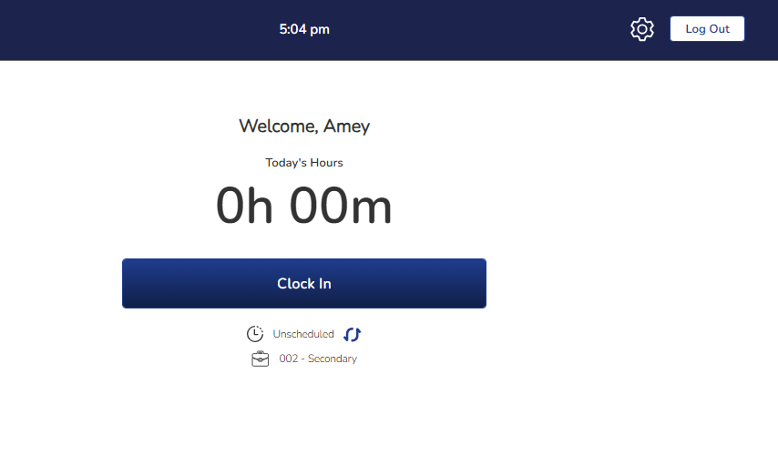

Account Setup

Setting Up Employer Account
- Registration email: New employer admins receive a “Register Now” email when UZIO support team add their company in the UZIO system. Click the link to set your username and password and complete the employer profile.
- Add additional admins/managers: Go to Manage Users to create roles and grant access (e.g., Payroll Admin, HR Manager) to users of these roles. You can limit access by function or location.

Setting Up Employee Account
- Invite & self-registration: Employees typically receive an email with a registration link to create their username and password (employee self-service).
  - The new hire gets the registration email when they are invited for self-onboarding.
  - The existing employees gets the registration email as soon as they are added into the list of onboarded employees.

Login as Employer
- Go to uzio.com and choose Employer from the login drop-down to reach the employer sign-in page. If you have already registered, log in with your credentials.
- Forgot password? Use the “Need help logging in?” link on the login screen to reset your password securely.

Login as Employee
- Access the Employee login from the same drop-down on uzio.com (or from your employer’s invite link), then sign in with the username/password you created during setup.
- If you can’t sign in, click Need help logging in? to reset your password; once login, you can manage pay stubs, W-2s, direct deposit, time off, and time tracking as enabled by your employer.
